UX and Product Design Methodologies

  - Discovery
Communication preferences
Gather requirements
Heuristic Evaluation
Usability Review
Competitive Analysis
Stakeholder Interviews
User Interviews
Business process review
Document requirements
Competitive intelligence
Market research
  - Design
Personas
Scenarios
Wireframes
User Journey Map
Information Architecture
Interaction Design
Visual Design
Security Plans / Reviews
Marketing plans
Release Timing
Recommendations
Sign offs
  - Develop
Create Design Assets
Low Fidelity designs
High Fidelity designs
Final Designs
Visual Designs
Style Guides
Mock Ups
Marketing materials
Sales materials
Writing for the Web, marketing and sales writing
Design product identities
Design logos
Hand Off

  - Deploy
Usability Testing Design
Preference test logo designs
Verification
Design Review
Approval
Go Live
  - Iterate / Repeat
Post Mortem
Bug Review
Usability Testing
A/B Testing
Collect and analyze customer feedback
Analyze metrics
Iterative design planning
Governance
Store tagged project documents
Post mortem
Plan next sprint, phase, or version

User Research Methods Overview
There are about 20 basic methods of user research that generally fall into Qualitative vs Quantitative dimensions, and attitudinal or behavioral.
  - Qualitative methods gather research about behaviors / attitudes directly – like User Interviews.
  - Quantitative methods gather research through indirect methods, analysis & surveys – like Clickstream Analysis or A/B Testing.
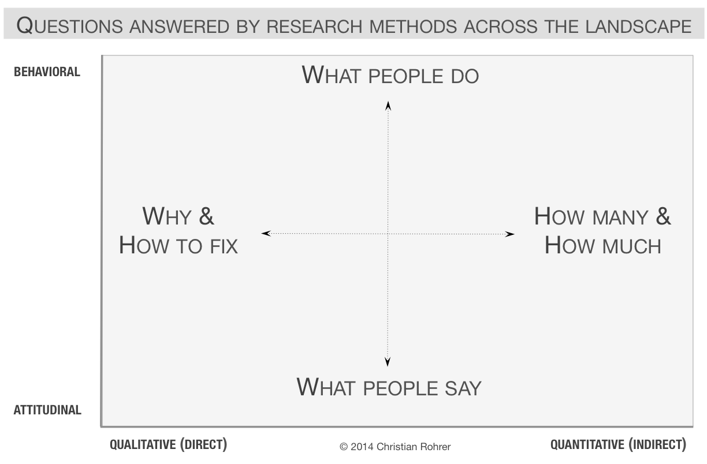
Testing provides differences between what people say they want and what they actually choose when presented with a choice –
- Attitudinal
- Behavioral
Qualitative research techniques are better at why or how to fix problems, and feeling level issues, while Quantitative research is better at how many and how much – analysis boils down to math.
What is important is deciding what the development and design team needs to know to create a better product, and the need helps determine which kinds of testing to perform.
Product user testing I find to be the most exciting because you can hear and see actual users interacting with it. There are 4 classic forms, which I learned from doing user testing with my friend Kelly Franznick, the truly kind co-founder of Blink in Seattle, Washington.
Patient, calm, cool, observant, a natural born teacher, Kelly explained “how and why” as he formally tested a Fortune 50 firms product design that I knew needed redesign – but not only for the reasons I already understood.
Later he showed me more of his techniques while we were testing a brand-new application for a large insurance firm. The PMs, designers, developers and companies all profited from Blinks usability testing, but I feel I benefited the most.
Of the 20 basic types of user research methods I have performed the following 14 types:

- Usability-Lab Studies
- Ethnographic Field Studies
- Participatory Design
- Focus Groups
- Interviews
- Usability Benchmarking
- Moderated Remote Usability Studies
- Concept Testing
- Customer Feedback
- Desirability Studies
- Card Sorting
- Clickstream Analysis
- A/B Testing (aka “multivariate testing”)
- Email Surveys (or via Survey Monkey)

From a List of 20 Basic Types of Research Methods from https://www.nngroup.com/articles/which-ux-research-methods/

UX Research Testing performed for the following organizations

  - Amazon
  - Bank of America
  - Boeing
  - Capital360 Bank
  - Comcast NBC Universal
  - Costco
  - Intel
  - Juniper Networks
  - LAUSD
  - Microsoft
  - Motorola Solutions
  - Premera Blue Cross
  - State of Washington
  - University of Washington
  - Visa

Processes

Research
Gather Product Requirements
Collect and Document Stakeholder Needs
  - Metrics -
request metrics collection be established
test metric collection efforts
analyze metric collection results

  - Surveys –
write survey questions
announce and give surveys
collect and analyze survey input
collect and collate user surveys conducted in person
design email polls
interpret user input and move it into user journey map
perform statistical analysis
cluster qualitative studies
review clusters

  - Interviews –
conduct contextual inquiry to see and document what users do
conduct and attend bi-weekly meetings
collect feedback and input on designs
from stakeholders across the globe
including night or early morning hours
interview client stakeholders via video conferencing
collect user feedback on versions
organize and conduct stakeholder interviews
do phone and in-person interviews

  - Roles –
plan and create personas
implement reviews based on personas
do ethnography data collection and analysis
perform heuristic analysis
- optimality
- completeness
- accuracy/precision
- timeliness
write user stories
research corporate needs from existing documentation
conduct card sorting meetings
create experience maps
create empathy maps
document service blueprint needs and processes
create portal to display database information and all related IT based on interviews
advise on web-based ADA-compliance

  - Test, Analysis, Advise
Test
plan user acceptance testing
advise unit testing
conduct remote user testing around the world simultaneously
collect benchmarking results

  - Bugs
configure bug reporting software
test & report bugs
review and stack rank bugs assign values
analyze bugs
guide regarding global test planning

Search
test search
advise on changing search output

Security
advise on Web and mobile application security
advise on spending to preclude security issues
research and hire security test team
review test team results

  - Choose Features
design and conduct A/B multivariate testing
analyze and advise on product features
stack rank product requests and requirements
stack rank features
set strategic goals in a variety of settings and needs
edit application specification documents
perform market analysis
advise on and revise technical specifications

  - Manage -
Act as UX facilitator and advisor -
create communication preferences list
communicate status with clients
attend scrum and stand ups
act as stand up lead for agile meetings
plan environmental (server) timing
review service level agreements
request support of SLA agreements

  - Manage Teams
evaluate resumes
interview job candidates
hire candidates
review employees
move employees to other jobs based on enhanced skills
Instruction
make presentations
train employees to make sales presentations
train people how to interview

  - Teach
UX / UI design to developers / PMs / junior designers / managers
information architecture to students
color theory
empathy and compassion theories
marketing techniques and how to research them for analytics
security issues

  - Review and Invent New Research & Design Techniques -
Stay up to date with new techniques, or speak on them
read sites and published research
Be open to new possibilities
take classes, attend conferences
social networks, attend meet-ups
Puget Sound SIGCHI, UX Book Club, UX Professionals Association, etc.

Design
  - Use results of research observations and artifacts documentation create designs
Update existing software designs based on user surveys and input from interviews, written feedback and test
  - Information architecture -
- structure information architecture
- create information architecture frameworks
- wireframe information architecture
- seek feedback on IA
- integrate IA with lo-fidelity wireframes
- integrate IA with Search
      - test, iterate
      - seek user feedback on
        - usability, findability. clarity
create hi and low fidelity wireframes
create prototypes in a variety of visual software
create designs for information graphics
script text display
research image and text display methods
imagine original design ideas
utilize scripting and coding capabilities to support design methods in new ways
conduct design critiques and post mortems
document and post artifacts to group site
localize websites

  - Product identity and marketing
- design product identifiers
- create logos
- choose color palette
- strategize and define visual feeling, select photos
- draft content
- strategize marketing

Design Examples https://www.wonderlane.com

ecommerce platforms
order specification end-to-end recycling lifecycle of secure handheld devices
cloud security
early warning web based / smart watch compatible notification system for servers
engaging digital workplaces
partner portal
design federated search
advise on development of database output design
roadmap planning software
corporate intranet sites
visual coding software
bug tracking software
high end credit card user dashboard & support request specifications
online help support
attendance system

Please read more details below:
Vertical Domains
  - I’ve done consulting & product / program management in user experience product innovation strategy, research, content, marketing, design for Cloud security

Portals, for partners and customers
Dashboards
Education and Intranet site design
Enterprise architecture
4 global sales forecasting apps $93B+ USD
Mobile / responsive apps
Roadmap
Business intelligence database
High end credit card registration and activation
Windows product activation, security, & anti-piracy
Social media; groups and members directory
Planning, UML
CRM and ERP
eBook
Knowledge base management
Telecommunication
Research; public education attendance and data visualization
Information design
Gamification
AI data bot
Search | SEO | Federated search software services
Ecommerce
Spec'd and designed ecommerce applications for Microsoft and Amazon
Managed teams creating approx. 50 ecommerce sites from 1999 – onwards\Marketing & branding
Social media; groups and members directory
Streaming media, audio & video
Customer identity
Cell technology
​Pre-sales presentations, staff training​
Vehicle reservation and ticketing
Server Notifiers
Desktop applications
Insurance applications
Geo-location
Technical Writing; code of conduct, terms of use
Order management and processing
Employee purchase plan / home use plan
Admin toolkit & controls
Support software – incident tracking
Broadcasting and cable television

SDLC Systems Development Life Cycle Process

  - One of the largest issues in design is defending one’s ideas and supporting research as required as an investment in product design. I feel that learning is the chief skill to pursue.
  - Hope this information is helpful, thank you,
  - -Linda
L. M. Lane, BFA MSIM
Bachelor of Fine Arts in Fine Art, Cornish
Master of Science in Information Management, University of Washington
Washington State
206-850-4452
wonderlane@gmail.com
  - https://www.wonderlane.com

